Lecture 2

TEACHING WITH SENSE OF HUMOUR – “HUMOUR AN EFFECTIVE MEDIUM OF TEACHING”
Everyone loves a teacher with an infectious sense of humor. Looking at the lighter side of life not only fosters cordial relations between professors and students, but also provides welcome relief while trying to follow a difficult lecture on a complicated subject. When there is a willingness to change, there is hope for progress in any field. Teaching is a challenge. Learning is a challenge. Combining both effectively is a challenge. Being humorous is a challenge. However, laughing is easy. We are convinced both by experience and research that using humour in teaching is a very effective tool for both the teacher and student.
Humor strengthens the relationship between student and teacher, reduces stress, makes a course more interesting and if relevant to the subject, may even enhance recall of the material. Humor has the ability to relax people, reduce tension, and thereby create an atmosphere conducive for learning and communication. Numerous studies in the field of advertising have noted that humor is the most effective tool for enhancing recall of advertisements.
It is easy to create a humor in the classroom by reading books of jokes and to listen to professional comics. The students should be encouraged to take notes, especially to learn about the professionals’ use of such techniques as exaggeration, pauses, and timing. Observe reality and exaggerate it - much humor lies in observations about real life and truthful situations. In conclusion, humor not only plays an important role in the healing process but is also very important in education.

(3) Z TO A APPROACH
This approach attempts to explain the application part of a particular concept first. The teacher should explain the application of a particular concept first and explain the effects of such applications. For example in management subject - motivation is explained in a manner that the organization get extensive benefits out of using some techniques like promotions and awards. So here the use of promotion is explained first and later students would get interest in knowing what are promotions and awards. The teacher starts explaining what is promotion and explains what motivation theory in management is.Another example we can try is that in accounting the Income statement and Balance Sheet can be explained first and later drawing their attention to double entry system of book keeping.
Strengths
- Makes a particular concept clear
- Students develop interest to know exactly the concept.
- Creates long lasting memory/correlation of a concept.
Weaknesses
  - Take quite long time for a teacher to introduce a concept
  - Initial difficulty in understanding a particular concept will be encountered.

Chart 5 - LEANING TOWER OF PISA EXPERIMENT – EXAMPLE TO Z – A
APPROACH
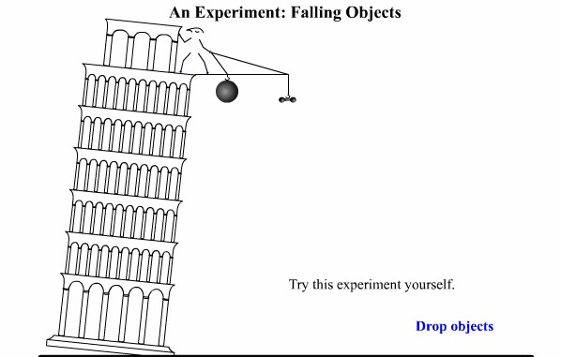

Source: vision learning
Z – A approach is explained in the following two charts. In the first chart a man drops cannonball and lead weight from the top of the building. Hypothesis for this experiment is both the object will fall at the same rate
In the second chart the cannon ball and lead weight have reached the ground.
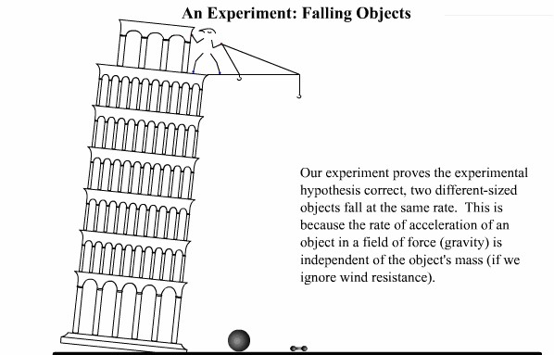

Source: vision learning
Concept Simulation - reenacts Galileo's experiment of two different objects falling at the same rate.

The above chart explains the application of that Gallileo’s theorm. Here the teacher explains how two objects reach the ground if they are put from a particular distance from ground level. Traditional way of teaching method will be explaining the theorem first and followed by its application. But this Z-A approach goes opposite in a manner that the proof or application is explained first and later the theory. Then it is explained that this the concept developed by Galileo. The above example of tower depicts a (possibly mythical) experiment in which Galileo dropped two objects from the leaning tower of pisa to demonstrate their comparable rate of descent.

(4) MNEMMONICS WORDS- WORDS –WORDS APPROACH
Here the teacher is not supposed to talk on a particular concept for a quite long time. But to make it clear to the students he can just go on saying mnemonics or its associated meaning in words. Here he goes on saying only words instead of sentence, and once they come to a basic understanding of the meaning of a particular concept then the teacher will explain in sentences. For example in teaching language courses this technique can be used as an effective medium by the teacher to develop word power.
- Dictionary must be used widely
- Word power increases
- Teacher also gets to know many words pertaining to a particular concept.

(5) ROLE PLAYING AND SCENARIO ANALYSIS BASED TEACHING
Role playing and scenario analysis is mostly used in organizations that try to analyze a problem pertaining to the organization, and this is also used in management institutions. But the similar kind of practice can be tried in other specialization too like science and engineering. Science and engineering courses have practical but in support of those practical if students are given a scenario and other options to solve a particular issue, then the students are exposed to decision making in a given environment.
For example, in teaching accounting the role of accountant can be explained by role playing technique. Invoice and bills can be given to students and asked them to assume the role of accountant. Here the real entries pertaining to transactions are made by the student and this is more practical approach to teaching where theory is supplemented by proper practical knowledge. Similar kind of technique can be applied in management, engineering and science courses.

VI.CONCLUSION
Across the world, information technology is dramatically altering the way students; faculty and staff learn and work. Internet-ready phones, handheld computers, digital cameras, and MP3 players are revolutionizing the college life. As the demand for technology continues to rise, colleges and universities are moving all sorts of student services, from laundry monitoring to snack delivery online. At Columbia University, a real-time Web-based service called Laundry View lets students log on to a Web- based system to see which washing machines are free before they head to the laundry room. They can monitor their wash and can even program the service to e-mail them when their load is done.
Technology is also changing the classroom experience. The classrooms at New York University’s Leonard N Stern School of Business feature all sorts of conveniences for students and teachers. For instance, the room is wired with cameras for photographing whiteboards, so students can receive the images as digital files. In addition, tablet PCs, compact computers that allow you to write notes directly onto the screen with a special pen, replace the archaic projector. With the tablet technology allow professors to make notes on charts and spreadsheets and send them directly to their students' PCs and he will get a feed back from each student.

From the above, we can make out that the Information and communication technology has made many innovations in the field of teaching and also made a drastic change from the old paradigm of teaching and learning. In the new paradigm of learning, the role of student is more important than teachers. The concepts of paperless and penless classroom are emerging as an alternative to the old teaching learning method. Nowadays there is democratization of knowledge an the role of the teacher is changing to that of facilitator. We need to have interactive teaching and this changing role of education is inevitable with the introduction of multimedia technology and the spawning of a technologically-savvy generation of youths.
The analysis reveals some of the suggestions that the teaching community can practice in the classrooms. Ultimately the teaching people are satisfied when he could reach the students community with his ideas and views. So, teaching depends upon successful mode of communication and Innovation though we mean the changes that we propose to be included in our medium of communication or even inclusion of some other elements in communicating information.
The researchers recommend that the teaching would be highly effective if the teacher start to use the recent multimedia technologies like usage of computers extensively or some modifications in the conventional mode of teaching. The use of computers may be very well practiced in the environment where the use of such technology is highly possible, but there must be some sort of innovation which can also be practiced in an environment where such use of technology is on its way to growth. In those environments use of humor, role playing, words –words approach, Z-A approach are the ideas that can very well be practiced.
The researchers believe that the core objective of teaching is passing on the information or knowledge to the minds of the students. Any method using computers or modifying the existing conventional chalk-talk method are innovative if they ultimately serve the attainment of core objective of teaching.

VII. Research limitations
As the weaknesses that are explained in this research work are purely the views and perceptions of the researchers and which could not be generalized. Even the modifications suggested might suffer from other limitations. The researchers try to suggest some useful modifications which could be tried by teachers as innovative to get maximum results.

